**ColorPro Price File Install Instructions**

1. Locate and open the appropriate gross margin price folder.

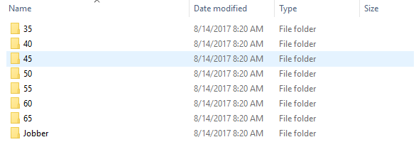

1. Copy all 3 files (COMPL, PACKG, PRICE) from the folder.

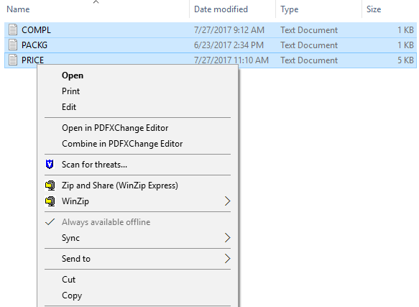

1. Open windows Explorer and click “My Documents” or “Documents.”
2. Double click ColorPro folder.
3. Right mouse click in the open window. Select “Paste.” A warning may appear asking to “Confirm File Replace.”

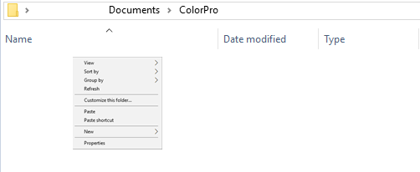

1. Click Yes.
2. Open ColorPro.
3. In the upper toolbar, choose Tools >> Prices >> Import.

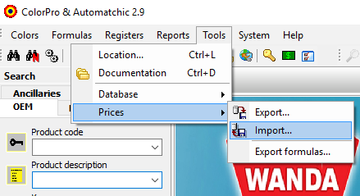

1. A box stating “File imported successfully” will appear.

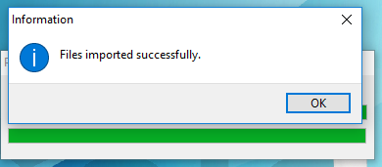

1. Click OK.

You have now successfully installed pricing into ColorPro.